Extraterrestrial Outbreak
(Team Bane Production)

Table of Contents
Game Overview 3
Game Outline 3
Game Synopsis 3
Setting 4
Target Market 5
Gameplay and Mechanics 6
Gameplay 6
Level Structure 7
Mechanics 8
Combat 8
Balance 8
Economy 8
Game Over.....................................................................................................................................9
Interface 10
Visual 10
HUD 10, 11
Menus 12
Control System 13
Audio 14
Sound Effects 14

Game Overview
Game Outline
Extraterrestrial Outbreak is a tower defence game with a twist. Utilising science fiction elements to allow complete creative freedom for both the developer and the player. Most tower defence games for the enemies along a set path which can become rather boring pretty quickly, this is not the case for TeamBaneTD - we aim to script the AI to find the shortest route around the towers thus challenging the player and creating longevity and variety. The game will be created using HTML 5 and is aimed to towards web browsers at the current moment with the possibility of it being expanded to other platforms depending on success.

Game Synopsis
Year 2030, the human race has discovered the existence of extraterrestrial life. The World Leaders decided to make contact with the extraterrestrial life but discovered that they were not seeking to establish a relationship but to eradicate the human race. The human race had barely managed to hold off an attempted invasion by the foreign life forms, the decision was taken to imprison the remaining extraterrestrial life captured during the invasion. It was decided that it would be inappropriate to house the hostile life forms on earth, therefore a maximum security prison was build just outside the earth’s atmosphere. This maximum security facility is a massive structure equipped with a highly sophisticated security system and weaponry system. Due to the incompetence of a worker within the facility’s control centre, there has been a massive security breach with all the facility’s occupants being released. As commander of the prison it is your duty to do whatever is needed to put a stop to the breach, you have at your disposal high tech weaponry to aid your attempt at curbing the attempted escape. It is crucial that you don’t not fail in your attempt because if the life forms manage to reach the facility’s escape capsules and make it to earth, it will surely mean the end of the human race.

Setting
Extraterrestrial Outbreak is set 18 years into the future in a fictional 2D environment where the human race has become more technically advanced and have been able to expand their reach out beyond earth and into the universe. The game is set within the confides of a maximum security prison facility built just outside of earth’s atmosphere.

Target Market
The audience we are aiming to target our tower defence game at is “traditional gamers”, what is meant by this is people from the age of 16 upwards to roughly 35 years old who are known to play games on a regular basis and are savvy when it comes to computer games. We feel we could have success with a marketing campaign aimed at those who fall within this age demographic because all of our research indicates that most people who play or are more likely to play video games belong to this demographic. We undertook research that showed there is a large tower defence market that could be capitalised upon. We will also be marketing the game towards anyone with a smartphone because it’s a market we can’t possibly ignore due to the enormous numbers of adults and young people who have smartphones. It is estimated that 30 % of adults within the UK own a smartphone and 50% of young people, this is an incredible amount of people that could possibly purchase our game, also games are the most popular paid apps bought by users of smartphones. We understand that a lot of people with smartphones might only play games for 10-20mins while sitting on the bus or the train to pass time but this is still an important market share. We hope that being inventive during development we can produce a game that can capture the imagination of those who might not necessarily be tower defence fans but might be intrigued and captivated by our game and its concept being of a SCI-FI theme, we hope it will capture fans of that particular genre also. We are not just simply aiming our game towards particular markets, but due to the greater possibility of sales within these demographics, they are our prime focus. The tablet market is also market we are having a serious look at due to the number of tablet users but at the current moment there is nothing concrete although that could change if we have success in the other markets.

Gameplay and Mechanics
Gameplay
The gameplay will consist of a drag/drop system, with players choosing a tower and placing it in the corresponding available tile. The player can choose where to place them out of numerous places, allowing him to create a maze for the creatures to run through, and making them take longer to escape the level.
We believe that creating a maze in a Tower Defence game is a unique enough feature to keep players coming back for more. Having this feature allows different people to play the game differently, and come up with unique strategies for the later, harder and longer levels.
The basic premise is:
- Towers cost gold
- Killing creatures grants gold
- The stronger the tower, or upgrade, the more gold it will cost to create/level up.
- The creatures gain health, speed or become greater in number as the game continues.
- The longer the game goes on, the more complex you can make your maze, due to the amount of gold given by the monsters, though you will need to either re-create older, weaker towers with newer ones, or upgrade your existing towers, it is a delicate balance.

Level Structure
The level structure is done in a simple way, it is one large square playing field. with an entry point for enemies and an exit point. The aim of the game is to stop the creatures getting from A to B. The level is laid out in a grid structure, allowing players to create their mazes accordingly.
Fig 1. Empty Playing Field
Fig 2. Example of Basic Maze
Above are examples of the playing field, and a very rough example of a basic maze. This maze would cause the creatures to run up from spawn, circle back on themselves and then once more again.

Mechanics

Combat
The combat in the game will be driven by the tower damage/creature hp scaling, with each level the minions gain some extra health, become faster or become greater in number. If there is a blockage in the maze (there is no way to possibly pass), the minions will instantly destroy a tower to create a path to the exit as a failsafe.

Balance
Once of the main issues that will be faced in creating the game will be the nature of balance. Making sure that the nether, the player’s towers or the enemies easily overpower the other. This becomes even more of a problem when it comes to the tower upgrades and enemy scaling.
As the enemies scale the towers can be upgraded to allow the player to keep up with the new more formidable opponents, this leads to the problem of balancing the upgrades along with enemy escalation. There also becomes the issue of Economy and that is as the enemies power up should the gold the player receives for each kill be the same, this could be used to slowly increase the difficulty of the game and makes sure that the player cannot just blitz the entire screen with top tier towers.
No stats have yet been confirmed for any of the enemy types or towers so balancing has not yet started, but this is seen as the main issue with tower defence type games and getting the balance right will make or break not only the flow but the overall playability of the game.
Economy
The entire game is run by the gold income from destroying the creatures. You gain a certain amount of gold per creature, and upon level completion. You use this to then create more towers - or upgrade your already existing ones.
We haven't yet figured out the exact gold income per creature, or level. That will require extensive testing and more than likely, numerous iterations(see Balance). The main point to tackle is making the player think about spending gold, or saving gold for better towers/upgrades.
Gold can also be reclaimed by destroying already built towers, but the player will only receive a fraction of the original gold spent on the tower. Of course an Upgraded tower will offer more gold than an simple tower but it will still be a fraction of the overall cost of that tower plus upgrade cost.

Game Over
Game over is reached when enough of the enemies escape the players maze alive. This is seen as a possible endless game there is no limits to the number of waves that can be thrown at the player and as such is an even growing challenge.
There is also the possibility of using balance to create the illusion of a game end or increase replay ability, by deliberately unbalancing the game after a certain point the player will be forced to ask themselves if they could have done something different and replay the game with the sole purpose of defeating that level.

Interface
Visual System
HUD
The design of the UI is has to be catered to the type of game that is being designed. In this case the game will be a tower defence game. The interface elements such as the tower selection window or general information window have to be away from the game screen where all the game activity will take place. The windows also must be within an adequate distance from one another. This will make it easier for the player to check their game status such as wave, money and time and make a decision based on the information displayed.

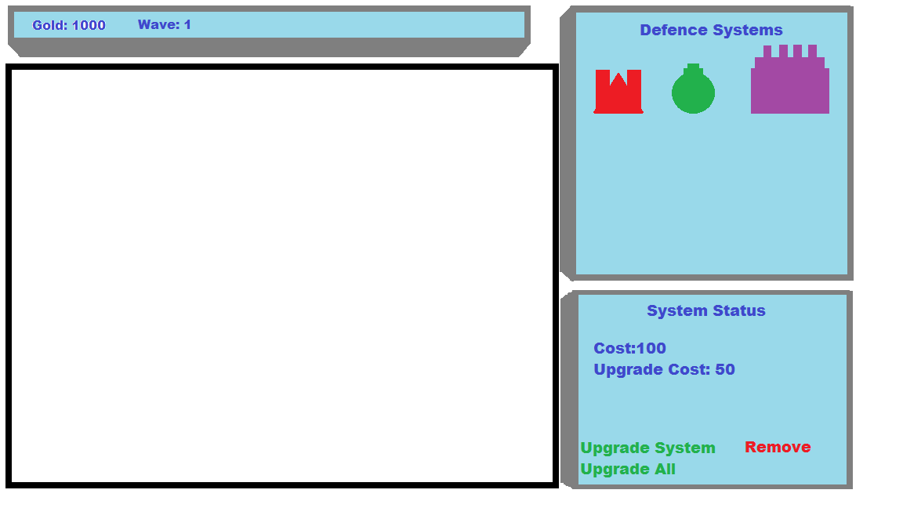
The first design was an attempt at balancing the screen space and keeping to the mentioned general structure of the interface. The game status bar is at the top of the screen as it would naturally be where the player will look. The tower selection window is on the side as it allows grid layout. The size of the side window allows for the tower icons to be clearly displayed.

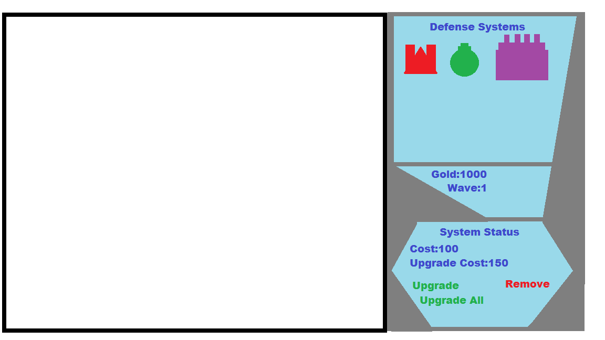
The second design was an attempt at keeping all the information on the side. This style of interface would make tower management easier and the game screen would not be cluttered with other UI elements. The design of the windows was also an attempt on tying in the sci-fi theme of the game. The size of the windows have changed only by a small amount as to flow with the design and still give the majority of the space to the game screen. However the change in the screen size and shape makes the display space somewhat limited compared to the first design attempt. The layout of the displayed information shows the limited space of the design.

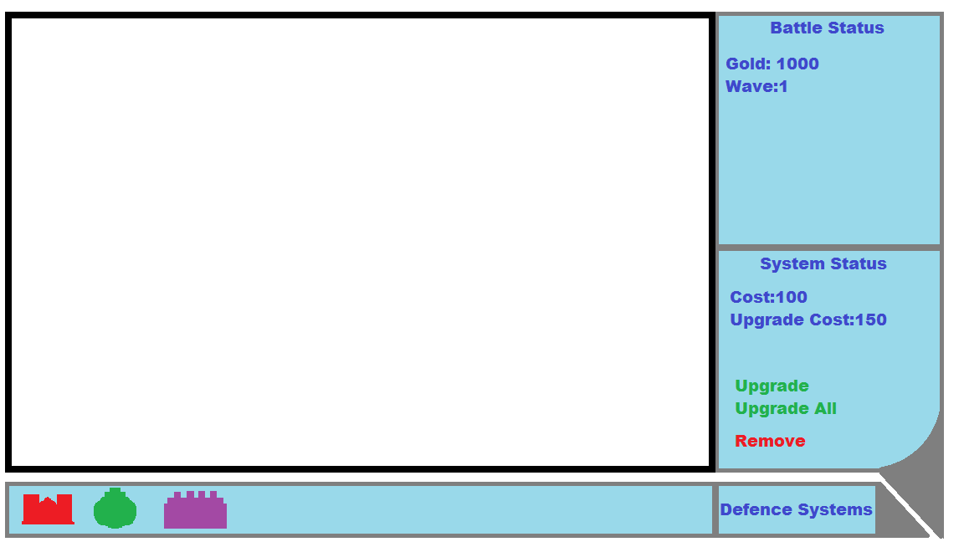
The third of the designs is an attempt at both applying a sci-fi theme and an easy to understand interface. This iteration of the design has the tower selection in the form of a bar on the bottom of the screen instead of as a window on the right side. The general information is displayed on the right side in the form of a window. The sci-fi aesthetic has been toned down from oddly shaped screens to a rounded corner in the lower window as well as out sharp triangular corners. This is to accommodate for more practicality in displaying information as the screen displaying game statuses is unaffected.

Menu
We went with a menu in keeping with the Sci-Fi theme of our game. We went for a basic menu regarding what would be included ‘Play’ button, ‘options’ button and a ‘credits’ button. Within the options menu well will include an option to turn music and sound on or off, instructions on how to play the game and difficulty settings. Finally everyone involved and those who allowed us to use their work will credited within the credits.

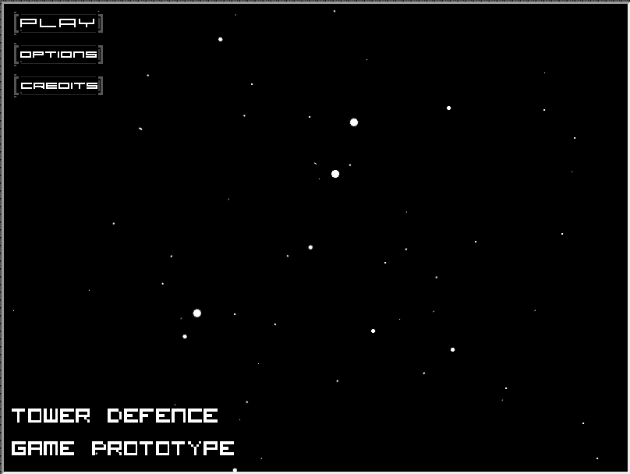
Control System
We are going with a control system which is common but synonyms with tower defence games. The player will be only able to use the left button on their mouse like most tower defence games, this will help ease of use for players and this would allow us to implement touch events for possible transition to mobile devices/tablets.
Left Button: Use for selection of towers, upgrades and navigation.

Audio
For the audio meaning sounds/music of our game will be sourced from freesound.org which is a site that contains a huge catalogue of audio snippets, samples, recordings, bleeps, under Creative Commons licenses. Also we will be sourcing sound effects by using SFXR which is an 8bit sound effects application. As of the current moment we have decided to leave audio till our game takes shape as we feel we can include music and sounds which match the tone of our game and are appropriate.
We have however basically decided on the sound of our menu which can be found on freesound.org, link of sound is as follows: http://www.freesound.org/people/suonho/sounds/28091/ .

Sound Effects
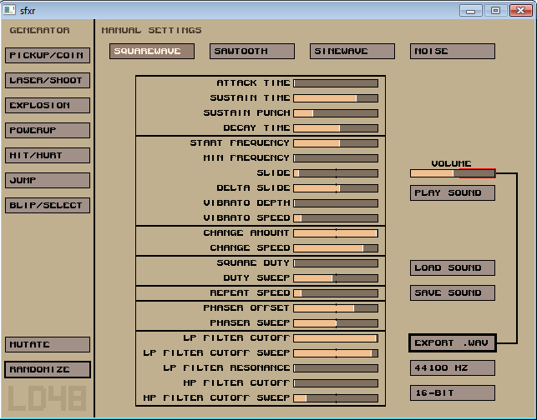
As already stated we plan to source sound effect using a 8bit sound effects application, screenshot of what said application looks like:

